**Virtual Machine**

Unit 1.2: VM Abstraction: the stack

1. Stack operations:

* push: add a plate at the stack’s top
* pop: remove the top plate

push and pop相当于完成了一次赋值

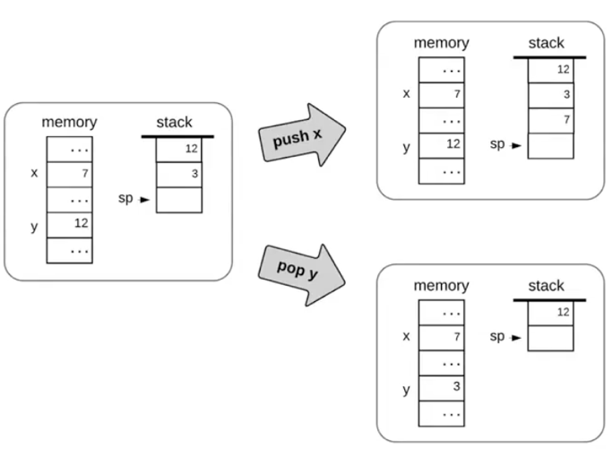

1. Stack machine is manipulated by:
2. Arithmetic / Logical commands
3. Memory segment commands
4. Branching commands
5. Function commands
6. Stack arithmetic

* add: the top two values
* neg: negate the top value

1. Applying a function f on the stack

* pops the arguments from the stack
* Computes f on the arguments
* Pushes the results onto the stack

箭头

Unit 1.3: VM Abstraction: Memory Segments

1. Variable kinds

* Argument variables
* Local variables
* Static variables

1. Virtual memory segments

1. The difference between push and pop:

**You cannot pop a constant**

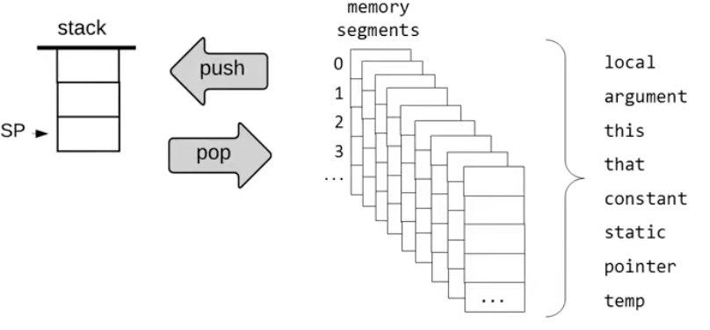

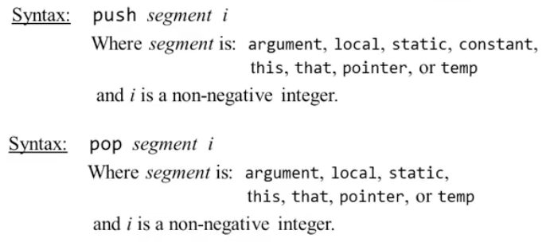

Unit 1.4: VM Implementation: the Stack

1. Pointer manipulation

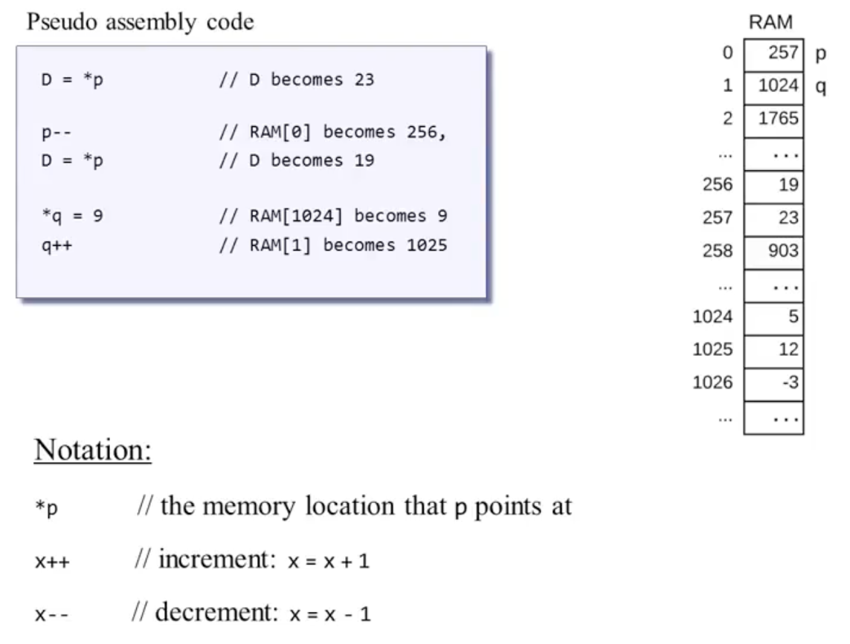

1. Stack machine

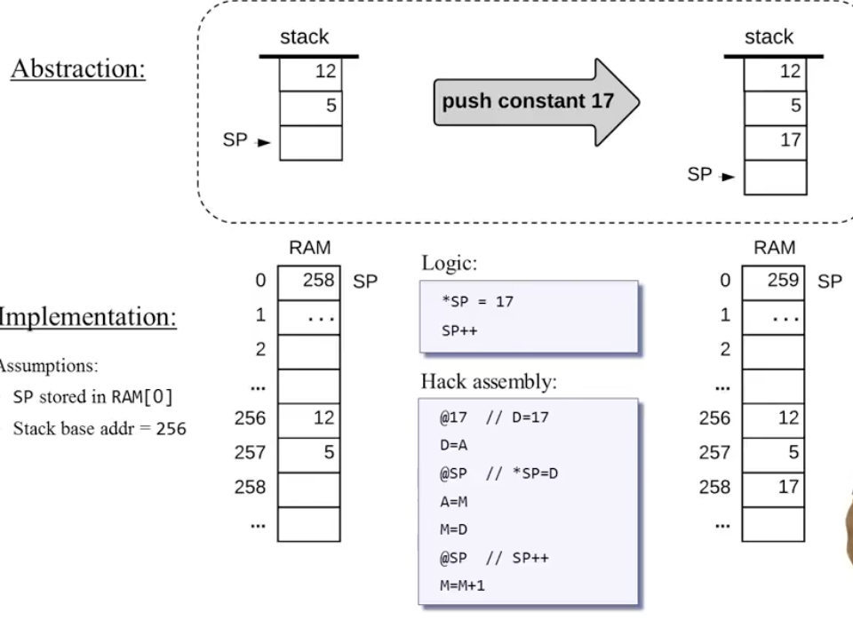

1. VM Translator

* A program that translates VM code into machine language
* Each VM command generates several assembly commands

Unit 1.5: VM Implementation: Memory Segments

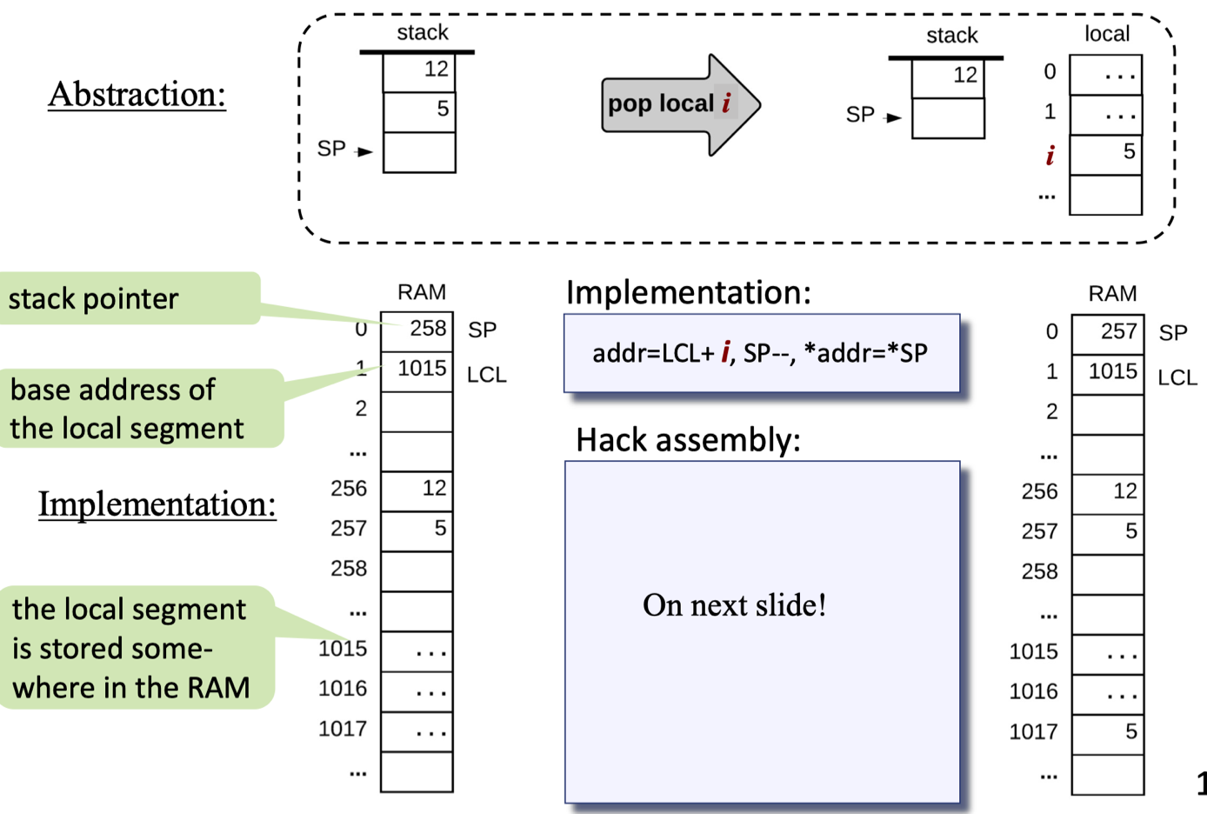

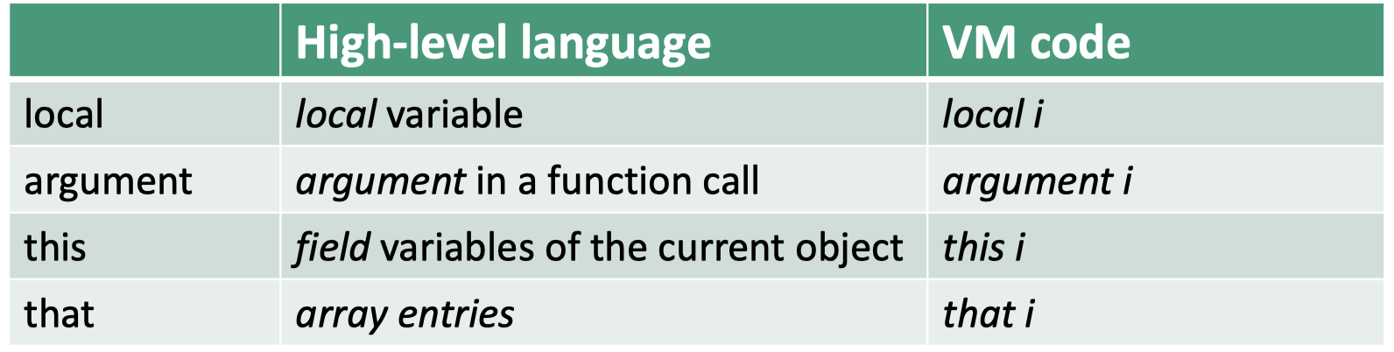

1. Implementing local, argument, this, that

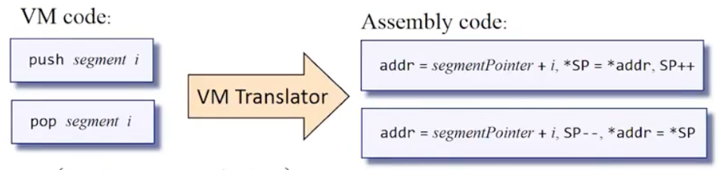

1. Implementing constant

1. Implementing static

1. Implementing temp

1. Implementing Pointer

Unit: VM: Branching Commands and Function Commands

1. Branching Commands

1. Abstraction of Function Command

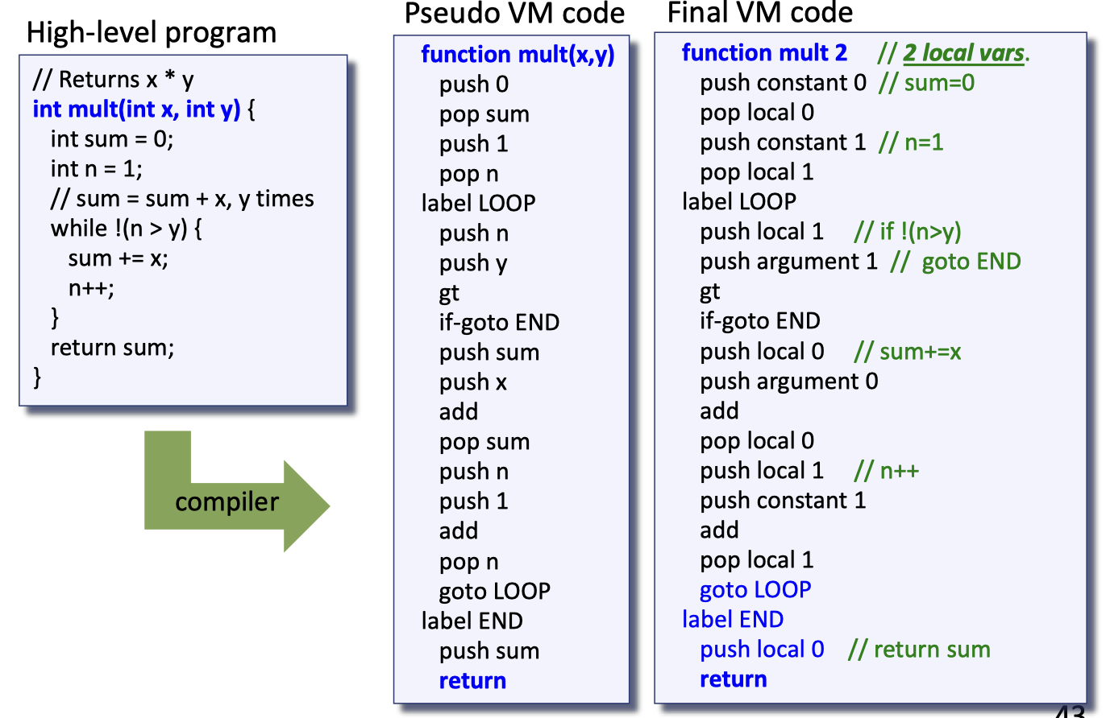

1. Implementation of Function Commands

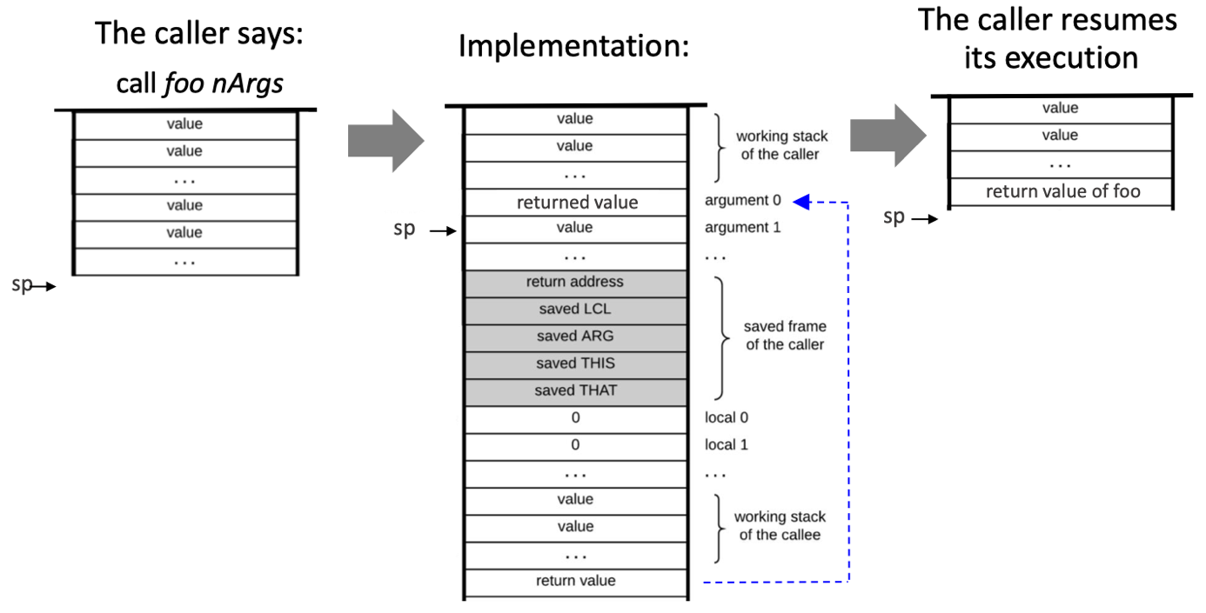

VM implementation (handling call):

1. Set ARG

2. Save the caller ’s frame

3. Jump to execute foo

VM implementation (handling function):

• Set up the local segment of the called function

VM implementation (handling return):

1. Copy return value onto argument 0.

2. Set SP for the caller.

3. Restore segment pointers of the caller.

4. Jump to the return address within the caller ’s code.

(note that the stack space below sp is recycled)

